*Week 8*

***Unit: :12***  **Language Focus 4**

**I . OBJECTIVES :**

- To practise the sentences in the simple past tense, the structures with”So, too, either, neither”

**II . LANGUAGE CONTENTS :** - The Simple Past tense

- The structures with”So, too, either, neither”

- Imperatives

- Indefinite quantifiers

**III . TEACHING AIDS :**- Lesson plan, text book.

**IV . TECHNIQUES :** - Example exchanges, Asking and Answering the questions

**V. PROCEDURES :**

**\* Activity 1 : Past simple tense (P. 123. 124)**

Look at the pictures (P.123). Practise asking and answering the questions (P.124) (Write sentences : Past simple)

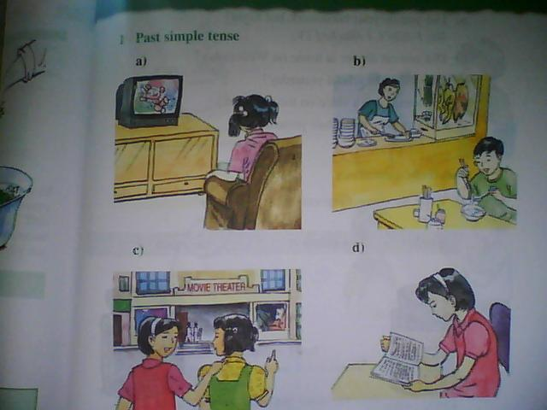

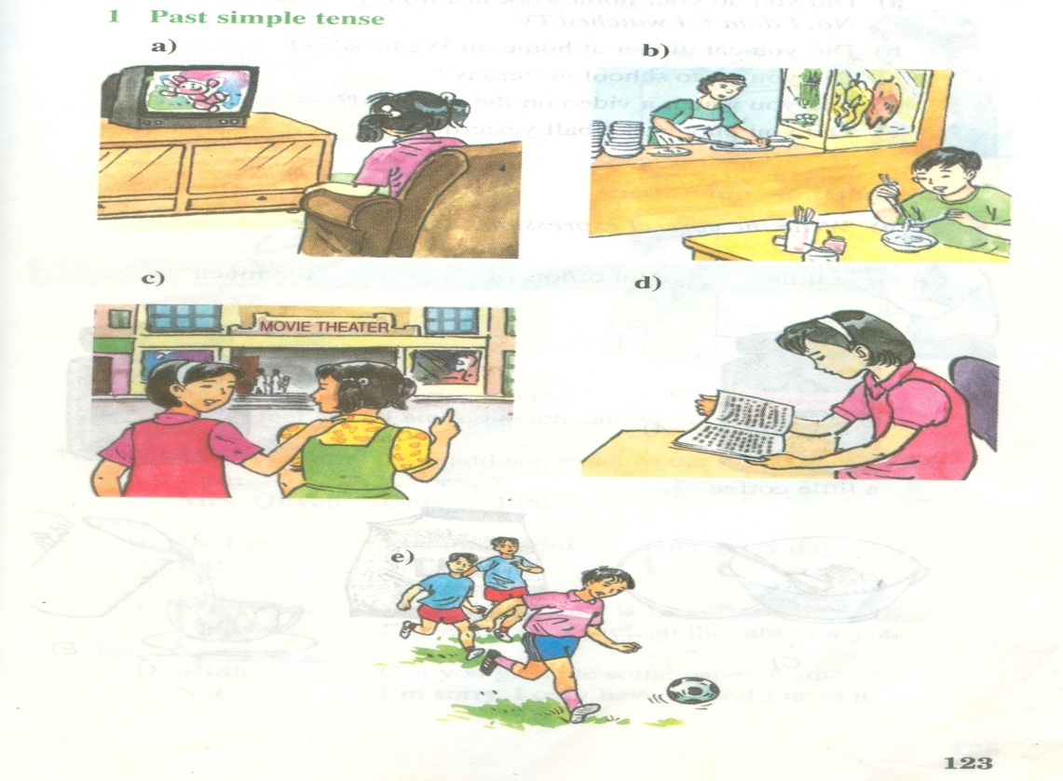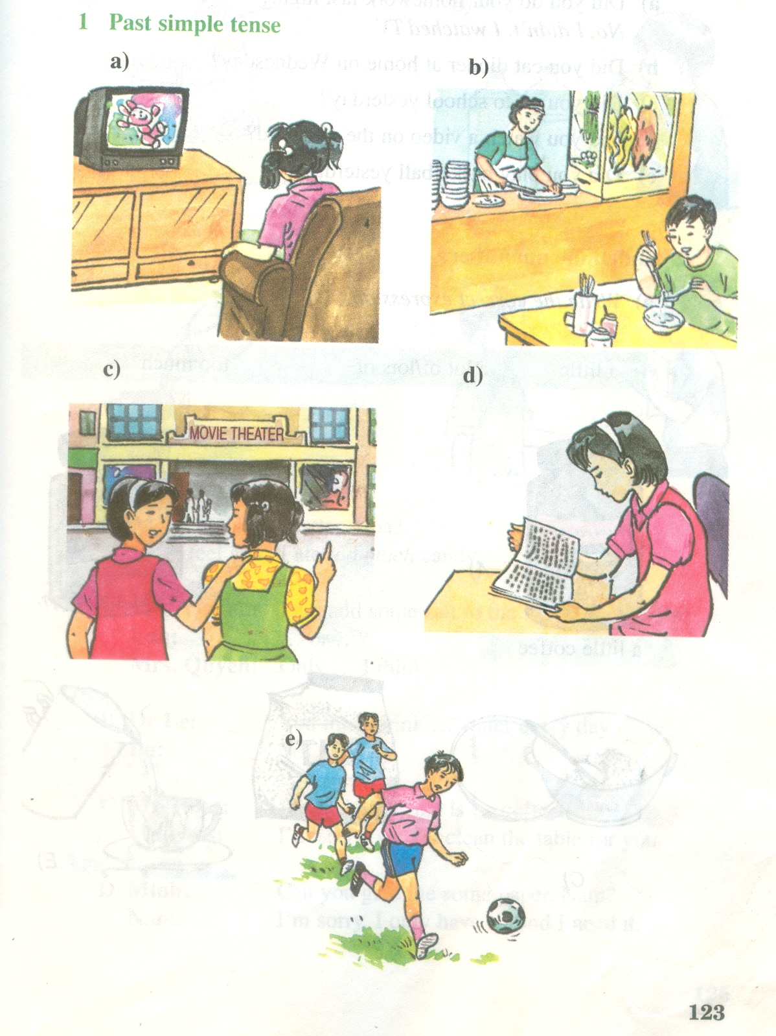





Answer the questions

a) Did you do your homework last night ?

b) Did you eat dinner at home on Wednesday ?

c/ Did you go to school yesterday?

d/ Did you watch a video on the weekend?

e/ Did you play basketball yesterday?

**\* Activity 2 : Indefinite quantifiers (P. 124) a. Write the correct expression**

**- A little: Mét chót, mét Ýt. Dïng víi danh tõ kh«ng ®Õm ®­ược.**

**- A lot of/ lots of: NhiÒu. Dïng víi danh tõ ®Õm ®ưîc vµ kh«ng ®Õm ®­ược.**

**- Too much: Qu¸ nhiÒu. Dïng víi danh tõ kh«ng ®Õm ®­ược.**

**a little a lot of/lots of too much**

**………………….coffee**

**……………………tea**

**……………………sugar**

**…………………salt**

**……....… water**

**b. Complete the dialogues**

**a)**

**Mrs. Quyen: Lan, add some salt to vegetables, please.**

**Lan:: .......... or ............**

**Mrs. Quyen: Only ............ .I think.**

**b)**

**Dr. Le: You must drink ..............water every day.**

**Ba: Yes, doctor.**

**c)**

**Mr.Nhat: Stop, please. That is ................ coffee.**

**Waitress: I’m sorry, sir.**

**I’ll clean the table for you.**

**d)**

**Minh: Can you give me some paper, Nam?**

**Nam: I’m sorry. I only have ............ and I need it.**

**\* Activity 3,4 : So and Neither (P.126. 127)**

**so: ®øng ë ®Çu c©u và đảo ngữ.**

**too: ®øng ë cuèi c©u**

**neither: ®øng ë ®Çu c©u và đảo ngữ.**

**either: ®øng ë cuèi c©u**

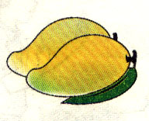

**a**) **Ba: I like mangoes.**

**Nam: I like mangoes,…………...**

**b)**

**Ba: I don’t like bananas.**

**Nam: I don’t like bananas, either.**

 Corn V

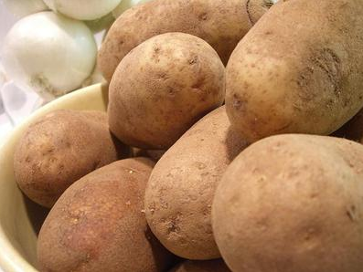 Pototoes X

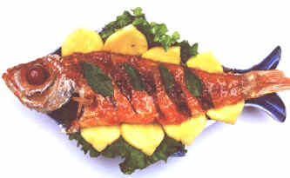 Fish X

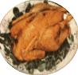Chicken X

**Read the dialogue**

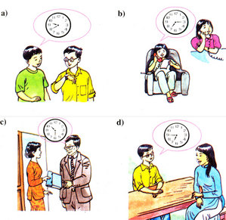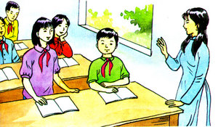 **Ba Nam**

**I don’t like bananas.**

**I don’t like bananas, either.**

**(Neither do I.)**

**\* Activity 5 : Imperatives (Complete the instructions)**

* Ingredients.

- 500 grams of cucumber

- 2 onions

- a small cup of vinegar

- one teaspoonful of salt

- five teaspoonfuls of sugar

**add mix peel slice**

**Stir wait wash**

a……. **the onions**

**b**..……. **the cucumbers and onions**

**c.**………**the cucumbers and onions**

**d**……..  **the slices**

**e**……… **a little salt, sugar, and vinegar to the mixture.**

**f**……  **the mixture.**

**g**…… **…for five minutes and the salad is ready to serve.**